American Rheinmetall Systems Success Story
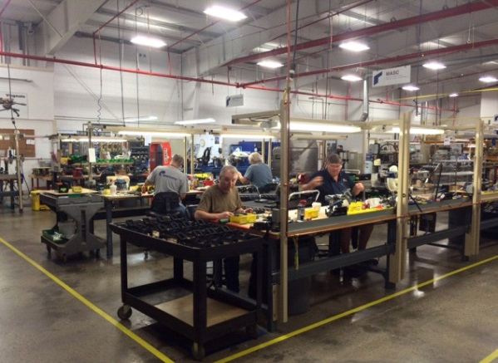
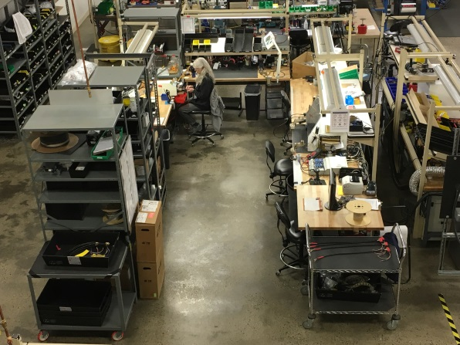
American Rheinmetall Systems (ARS) is a mechanical/electro-optical engineering company specializing in sophisticated system integration, assembly and R&D work. The Team works in close cooperation with customers worldwide and is a key sub-supplier to Kongsberg Defense & Aerospace for the US Army’s CROWS remote weapon station programs; producing mounts, firing mechanisms and video imaging modules (VIM). ARS is ISO9000:2015 Certified, situated in a modern, clean, and well maintained facility of 30,000+ square feet specifically designed and configured to support its product lines.

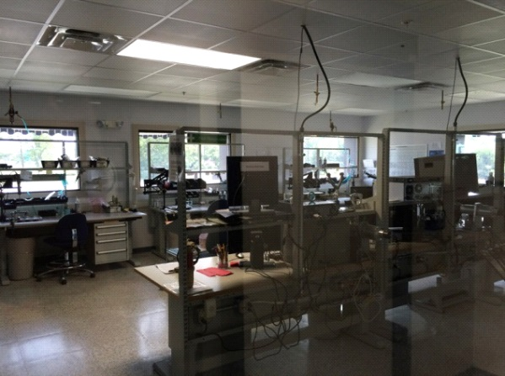
There are 20,000 square feet of floor space dedicated to the Production Line, and 2,600 square feet of Electrostatic Discharge Protected Area (EPA) compliant to ANSI/ESD S20.20-2014. Both areas can be easily expanded to adjacent unused space at minimal cost and effort if needed. ARS has embraced and promoted the Lean Manufacturing Concept in an attempt to decrease inefficiencies in existing processes, in order to streamline its operation, create more space and free up employee’s time to take on additional contracts.
Production Area

In its infancy, ARS was not equipped to produce cables for their existing solenoid and video imaging module (VIM) products, but in 2010, the decision was made to change that. A group of employees were chosen to become IPC Specialists, which started the process of integrating cable assembly into the production line. Through hard work and dedication, ARS has been successful in its endeavor to produce high quality, defect free cables that are then assembled into internally built units. Cable assembly has been such a positive addition to the work that ARS is capable of doing, that all of the employees on the production floor have become IPC Certified in preparation for additional cable contracts. ARS has produced a total of 15,292 cables since embarking on cable production in 2010, with 5,382 of those cables having been produced in a single year alone. For the past six years, ARS has been enthusiastically developing, producing, and expanding its capabilities as it pertains to cable and harness assemblies in order to be confident, competitive, and well positioned for future contracts.
EPA Area

Cable Manufacturing & Test
Cable Area
- Crimp Tools – Wire & Coax

- Daniels Manufacturing Corp. WA27F Pneumatic Crimp Tool
- Schleuniger OC3950 Pneumatic Cutting Machine
- Schleuniger 5300 Coaxial Cable Stripping Machine
- CAMI Research Inc. CableEye HVX Series
- Tyco Electronics T208M Label Maker
- Nicomatic Coax Crimp Tool
- TIE-DEX II Pneumatic Band-it Tool
- Milliohm Meter
- Multi Meters

Cable Area

