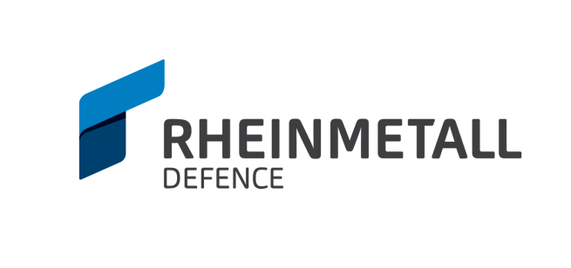 **Vingmate Success Story**

**American Rheinmetall Systems**

**Challenge:** Customer requested the option of being able to use both the BAE Systems UTC XII and Flir Hiss Thermal Optic Solutions with the Vingmate FCS, in addition to being able to connect an external monitor.

**Solution:** Design, procure, prototype, & produce cables to fulfill the demands of each of these additional applications with the customer’s specifications in mind with minimal turnaround time.

**Result:** The custom Hiss, UTC, and VGA cables supplied to the customer provided the flexibility required to use two additional optics packages, further increasing the capabilities of the Fire Control System and added the option of using any monitor with a VGA connection.

