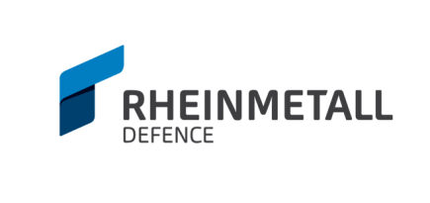
Core Cable Manufacturing Capabilities Certified to IPC/WHMA-A-620C
American Rheinmetall Systems, LLC 15 Morin St. Biddeford ME Tel: 207-571-5850

American Rheinmetall Systems (ARS) is an established provider of high performance mil-spec cables and cable harnesses. ARS has been a major supplier on several programs providing various cables to support OEM’s requirements. Cables can be fully customized based on requirement specifications, customer needs, and delivery schedule. Samples are available upon request.

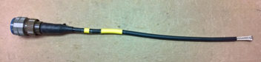
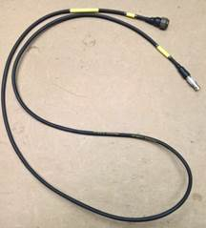
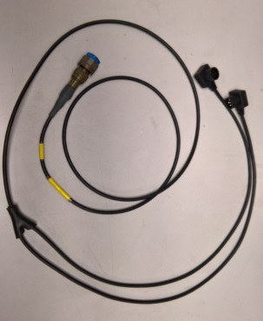
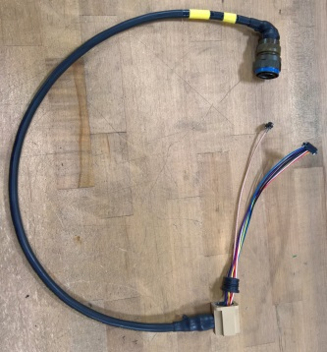
Applicable Certifications:
- IPC/WHMA-A-620C
- ISO 9000:2015 (ISO certified since 2008)
- ITAR Compliant

Available Equipment:

- Schleuniger OC 3950 (pneumatic wire cutter)
- Schleuniger CoaxStrip 5300 (programmable wire stripper)
- CAMI Research Inc. CableEye HVX Series
- TIE-DEX II Pneumatic Band-it Tool
- Crimp Tools-Wire & Coax
- Tyco Electronics T208M Label Maker
- Nicomatic Coax Crimp Tool
- Milliohm Meter
- Multi Meters
Extensive Experience with:
- MIL-DTL-38999 Series connectors
- IPC/WHMA-A-620C Class III cables
- DR-25 heat-shrinkable tubing
- Nicomatic CMM 200 connectors
- Circular Push Pull Connectors
- Coaxial Connectors BNC
- D-SUB

